***Parade* (Paris, Théâtre du Châtelet, 18 May 1917)**

**Summary**

A one-act ballet on the theme of a fairground sideshow, *Parade* was produced by Serge Diaghilev’s Ballets Russes, premiering on 18 May 1917 at the Théâtre du Châtelet, Paris. *Parade* marked a turning point as the company moved from the Orientalism of ballets such as *Schéhérazade* (1910) towards the modernist experimentation visible in *Le Sacre du Printemps* (*The Rite of Spring*,1913), though the extent of the ballet’s vanguardism has been debated since its premiere. According to Jean Cocteau, the poet who wrote the ballet’s libretto, the impetus for *Parade* originated in 1912 with Diaghilev’s command, ‘Astonish me!’ To fulfil Diaghilev’s mandate, Cocteau assembled a production team drawn from the Parisian avant-garde: for the score, he recruited the composer Erik Satie, known for experimental piano compositions such as *Gymnopédies* (1888) and for cabaret songs performed at the Montmartre cabaret Le Chat Noir. In 1916, Cocteau secured the participation of Pablo Picasso, a painter associated with the Cubist movement of the early 1910s, to design the overture curtain, set and costumes. Working with the choreographer Léonide Massine, this group produced a ballet-pantomime featuring characters familiar from the circus, variety shows and cinema. Mixing various forms of art and entertainment, *Parade* used dance to explore the unstable relationship between elite and popular culture.

Contrbution to Modernism

Cocteau’s concept for *Parade*, which revolved around the confrontation of high art with popular culture and of the avant-garde work with a mystified public, was rooted in the themes of nineteenth-century Symbolism. His ideas can be traced through several unrealised theatrical productions in the preceding years, including an adaptation of Shakespeare’s *A Midsummer Night’s Dream* to be performed at the Médrano Circus in Paris and a ballet entitled *David*, a fairground staging of the biblical story. Cocteau’s interest in engaging Stravinsky for the latter project signals a conceptual link with the popular Ballets Russes work *Petrouchka* (1911). Choreographed by Michel Fokine, with a score by Stravinsky and designs by Alexandre Benois, *Petrouchka* centred on three puppets – a Ballerina, a Moor and Petrouchka, a Russian equivalent of Punch or Pierrot – who are enslaved by a cruel Magician and forced to perform in his carnival booth.

The scenario for *Parade* solidified in 1916 as Cocteau solicited the collaboration of Satie and Picasso on the production. The poet envisioned a burlesque sideshow at a Paris fairground featuring three acts: a Chinese Conjurer akin to vaudeville magicians such as the blackface performer Chung Ling Soo; a Little American Girl derived from ingenues of stage and screen, including Mary Pickford and Pearl White; and a pair of Acrobats. In addition to musical accompaniment, the audience would hear the shouts of offstage carnival barkers attempting to lure the audience into an imaginary, invisible circus tent – efforts which ultimately would end in failure. As critics noted at the time, this narrative placed the Ballets Russes’ audience in the position of the *parade*’s viewers, blurring the boundary between onstage fiction and offstage reality.

When Picasso signed on as *Parade*’s designer, he altered the ballet’s scenario and thematic emphasis: he convinced Diaghilev to replace the off-stage barkers’ voices with three staged Managers who alternated with Cocteau’s three original *parade* acts. In several of Picasso’s sketches, these characters resemble sandwich men: figures wearing billboards suspended from their shoulders, a common form of walking advertisement. Eventually, this motif developed into over-life-size papier-mâché costumes for the ballet’s three Managers: a pipe-smoking, tuxedoed French Manager; an American Manager laden with fragmented skyscrapers; and a ‘Negro’ Manager on horseback, changed at the last minute to a performing horse. The disjunction between these Cubistically-rendered characters and the more mundane costumes for the *parade* acts echoed the contrast between the naturalistic overture curtain, a pastoral image of picnicking *commedia* performers, and the set, a Cubist-inflected cityscape. Satie and Massine’s contributions followed a similar format: *Parade*’s score juxtaposed a solemn fugue in the overture with march, ragtime and waltz music, and the choreography combined pantomime, a jig and a balletic pas de deux. The resulting fusion of high art and lowbrow entertainment proved far less shocking than Cocteau had hoped.

**Critical Reception**

Critical debates about *Parade* initially focussed on its aesthetic qualities. Touted as a daring Cubist experiment in the press leading up to its premiere, the ballet’s avant-garde credentials were challenged by several reviewers. Recent scholarship relates such aesthetic questions to broader political and cultural contexts. One interpretation, emphasising the ballet’s traditional elements, situates *Parade* within an increasingly conservative, nationalistic atmosphere intensified by the First World War – noting as evidence Cocteau’s involvement in the jingoistic weekly newspaper *Le Mot*; the Latinate theme of Picasso’s curtain, in line with his Neoclassical works of the late 1910s; and the organisation of *Parade*’s premiere as a benefit for wounded French veterans.

Another approach, which stresses the ballet’s popular references, views *Parade* as a self-conscious commentary on the public reception of modernism, characteristic of a complex dynamic in which modern art draws on the materials and strategies of mass culture, and vice-versa. Dance, a medium then undergoing a dramatic shift in status relative to the other arts, played a key role in bridging this divide. Associated in the late nineteenth century with lowbrow entertainment, dance came to be viewed as a form of high art during the modernist period – a process the Ballets Russes helped to initiate. *Parade* invoked both the highbrow and popular connotations of dance as well as film, another genre referenced in the contributions of Picasso, Satie and Massine. Combining dance and film onstage with characters who straddled virtual and real experience, *Parade* raised questions about the status of the body in the machine age.

**References and Further Reading**

Bellow, J. (2013) *Modernism on Stage: The Ballets Russes and the Parisian Avant-*Garde. Aldershot: Ashgate Press. (An art-historically oriented analysis of the Ballets Russes’ impact on the visual arts)

Garafola, L. (1989) *Diaghilev’s Ballets Russes*, New York: Oxford University Press. (A comprehensive overview of the history of the Ballets Russes)

Rothschild, D. (1991) *Picasso’s ‘Parade’: From Street to Stage*. London: Sotheby’s Publications. (An exhibition catalogue focused on the ballet’s sources and evolution)

Silver, K. E. (1989) *Esprit de Corps: The Art of the Parisian Avant-Garde and the First World War, 1914-1925*. Princeton: Princeton University Press. (A historically grounded account of the impact of conservative politics on the artistic avant-garde)

Steegmuller, F. (1970) *Cocteau: A Biography*. Boston: Nonpareil Books. (A detailed retelling of Cocteau’s career and private life)

Weiss, J. (1994) *The Popular Culture of Modern Art*: *Picasso, Duchamp, and Avant-Gardism*. New Haven: Yale University Press. (A comparative investigation of the relationship between modern art and popular culture at the turn of the century)

**Moving Image Material**

*Picasso et la Danse: Parade, Pulcinella Mercure, Cuadro Flamenco* (2008). (Brief clips of *Parade* staged by Suzanna della Pietra and performed by the company Europa Dance)

<http://www.youtube.com/watch?v=_Chq1Ty0nyE>

*Joffrey: Mavericks of American Dance* (2012). (American Masters documentary with clips of Léonide Massine restaging the ballet and Gary Chryst performing the Chinese Conjuror’s dance)

<http://video.pbs.org/video/2320387369>

**Paratextual Material**

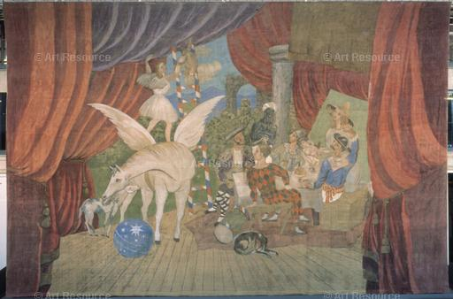

[Picasso, Pablo (1881-1973) © ARS, NY](javascript:Matrix3.mbClick=false;void(0);)

Curtain design for the ballet *Parade*, 1917. 10.5 x 16.4 m. AM3365P. Photo: Christian Bahier.

Location: Musée National d'Art Moderne, Centre Georges Pompidou, Paris

Photo Credit: CNAC/MNAM/Dist. RMN-Grand Palais / Art Resource, NY

Image Reference: ART160567

Image size: 3733 X 2460 px

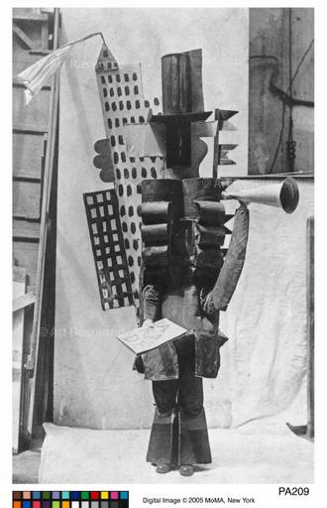

[Picasso, Pablo (1881-1973) © ARS, NY](javascript:Matrix3.mbClick=false;void(0);)

Maksymilian Statkiewicz as the American Manager in the first performance of the ballet *Parade*, Paris, Théâtre du Châtelet, 18 May 1917. Curtain, scenery and costumes by Picasso. (PA209)

Location: The Museum of Modern Art, New York, NY, U.S.A.

Photo Credit: Digital Image © The Museum of Modern Art/Licensed by SCALA / Art Resource, NY

Image Reference: ART371783

Image size: 2436 X 3780 px

Juliet Bellow